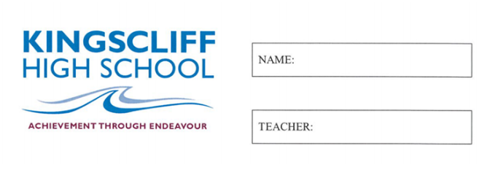

MATHEMATICS

Year 7

Practice Exam 2

2026

Time allowed: 50 mins
5 mins reading time
Instructions  1. Attempt all questions  2. Show working where needed  3. A calculator is NOT permitted |  | Sections and Marks  Part A (Multiple Choice) – 15 Marks  Part B (Calculations) – 30 Marks  Part C (Data and Probability) – 18 Marks  Total – 63 Marks

Part A
1. | Which word describes the middle value when the data is written in order?  a) Mean b) Mode  c) Range d) Median
2. | The mean of 3, 5, 7 and 9 is:  a) 5 b) 6  c) 7 d) 24
3. | Using the order of operations, 10 − 2 × 3 =  a) 24 b) 4  c) 30 d) 13
4. | Ascending order means:  a) Largest to smallest b) Smallest to largest  c) In any order d) Odd numbers first
5. | Which digit is in the thousandths place in 7.4925?  a) 4 b) 9  c) 2 d) 5
6. | 2 × 2 × 2 × 2 × 2 × 2 written in index notation is:  a) 2⁶ b) 6²  c) 2 × 6 d) 12
7. | Another word for a variable (a letter used in place of a number) is:  a) Pronumeral b) Numerator  c) Denominator d) Integer
8. | Two angles in a triangle are 90° and 40°. The third angle is:  a) 40° b) 50°  c) 130° d) 230°
9. | A triangle has two equal angles. What type of triangle must it be?  a) Isosceles b) Scalene  c) Obtuse d) Reflex
10. | Which of these jobs needs you to find a perimeter?  a) Carpet to cover a floor  b) Skirting board to go around the edge of a room  c) Water to fill a pool  d) Paint to cover a wall
11. | Which list is ordered from smallest to largest?  a) −1, −5, 0, 3 b) −5, −1, 0, 3  c) 0, −1, −5, 3 d) 3, 0, −1, −5
12. | How many outcomes are in the sample space when a standard six-sided die is rolled?  a) 1 b) 2  c) 6 d) 36
13. | If P(E) = 0, the event E is:  a) Certain b) Impossible  c) Likely d) An even chance
14. | An angle between 180° and 360° is called:  a) Obtuse b) Straight  c) Reflex d) Acute
15. | Co-interior angles on parallel lines:  a) Are equal b) Add up to 180°  c) Add up to 90° d) Add up to 360°

Part B
1. | Calculate the missing angle and provide working out. | 2  marks
  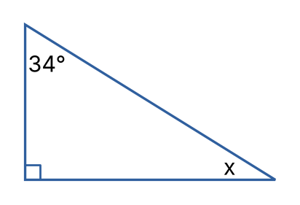 | _____________________  _____________________  _____________________  _____________________
2. | Calculate the size of the exterior angle marked a° and provide working out. | 2  marks
  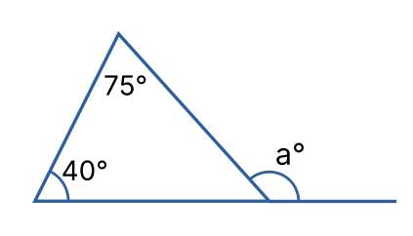 | _____________________  _____________________  _____________________  _____________________
3. | State True or False for each of the following:  a) 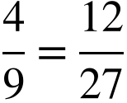 b) 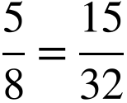 | 2  marks
4. | Calculate the following:  a) 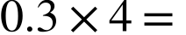 b) 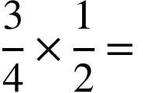 | 2  marks
5. | Calculate the following:  a) 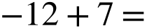  b) 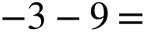  c) 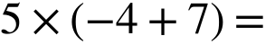 | 3  marks
6. | Convert into a mixed number:  a) 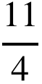  Convert into an improper fraction:  b) 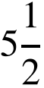 | 2  marks
7. | Write an algebraic expression for each statement. Use to represent the number:  i) The number increased by 8  ii) The product of 6 and the number | 2  marks
8. | If 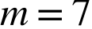, 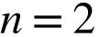 and 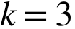  Solve the following by substitution:  i) 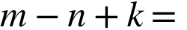  ii) 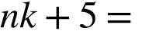 | 2  marks
9. | Simplify the following:  i) 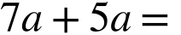  ii) 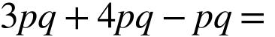  iii) 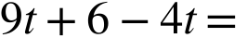  iv) 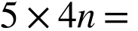 | 4  marks
10. | Calculate the following (use a mental or written strategy):  i) 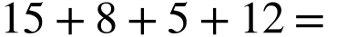  ii) 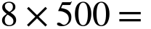  iii) 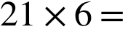 | 3  marks
11. | Solve the following equations:  i) 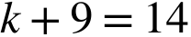  ii) 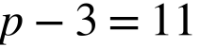  iii) 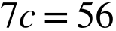  iv) 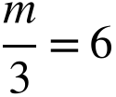  v) 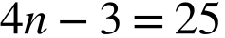  vi) 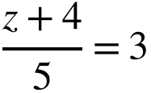 | 6  marks

Part C
12. | A survey recorded the number of people in each car that drove past the school gate:  1 2 1 3 2 1 4 2 1 1  2 3 1 2 8 1 2 3 2 1  i) Construct a dot plot from the above set of data  ii) How many cars were surveyed?  iii) What is the mode?  iv) What is the range?  v) How many cars had fewer than 3 people in them?  vi) Is there an outlier? If so, what is it? | 7  marks
13. | Observe the following set of data:  2, 8, 4, 6, 1, 7, 5, 9, 3  Calculate the following:  i) The mean  ii) The median  If 15 was added to the data set, what would be:  iii) The new median?  iv) The new mean? | 4  marks
14. | Observe the following graph and answer the questions below.  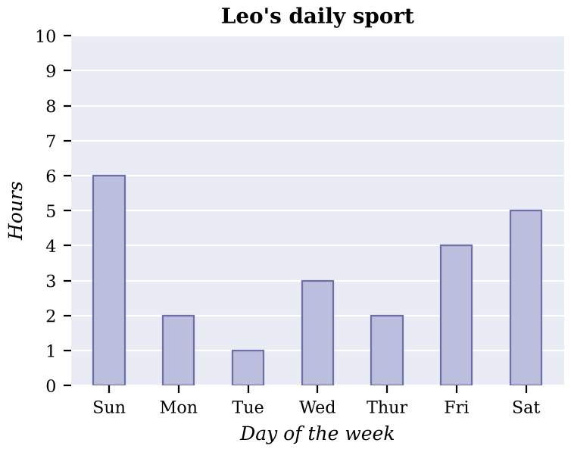  i) How many hours did Leo spend playing sport on Wednesday?  ii) On which day did Leo spend the least time playing sport?  iii) How many hours did Leo spend playing sport over the whole week shown?  iv) What fraction of Sunday did Leo spend playing sport? Give your answer in simplest form. | 4  marks
15. | 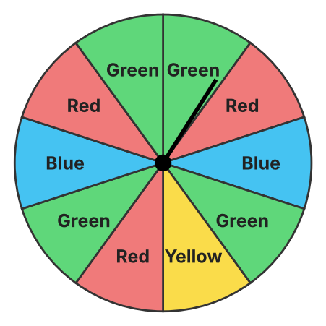  Observe the spinner above. Each section is the same size.  a) List the sample space:  b) What is the probability of spinning green?  c) What is the complement of spinning red, and what is its probability? | 3  marks

